R Output
> library(NCStats)
> library(MASS)

> FED <- read.table("FishEnergyDensity.txt",head=T)
> str(FED)
`data.frame': 64 obs. of 3 variables:
$ species: Factor w/ 4 levels "bayanchovy","bluefish",..: 2 2 2 2 ...
$ dw : int 39 34 34 32 31 30 30 29 26 25 ...
$ ed : int 10000 9000 8500 8100 7500 7100 7700 6100 5900 5500 ...

> attach(FED)

> lm1 <- lm(ed~dw*species)
> plot.resid(lm1,loess=F)
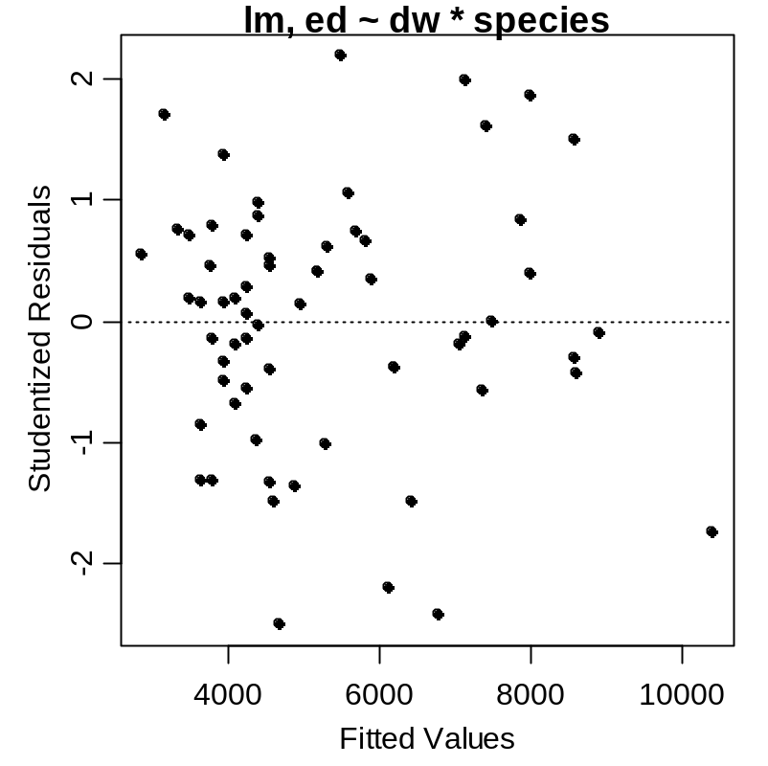

> ncv.test(lm1)
Non-constant Variance Score Test
Variance formula: ~ fitted.values
Chisquare = 1.728625 Df = 1 p = 0.1885866

> ad.test(lm1$residuals)
Anderson-Darling normality test
data: lm1$residuals
A = 0.353, p-value = 0.4549

> plot.diag(lm1)
2 predictors and 64 individuals
Unusual Observation Results
measure value cutoff inf obs
1 |Studentized Residuals| 2.49289 NA FALSE 20
2 Leverage 0.40041 0.14062 TRUE 1
3 |COVRATIO-1| 0.65118 0.14062 TRUE 24
4 Cook's Distance 0.24260 0.06557 TRUE 1
5 |DFFits| 1.41790 0.44353 TRUE 1

Data for Highlighted Individuals
obs ed dw species
1 1 10000 39 bluefish
24 24 3000 15 weakfish

> plot.fit(lm1,xlab="Dry Weight",ylab="Energy Density")
> highlight(ed~dw,pts=c(1,24))
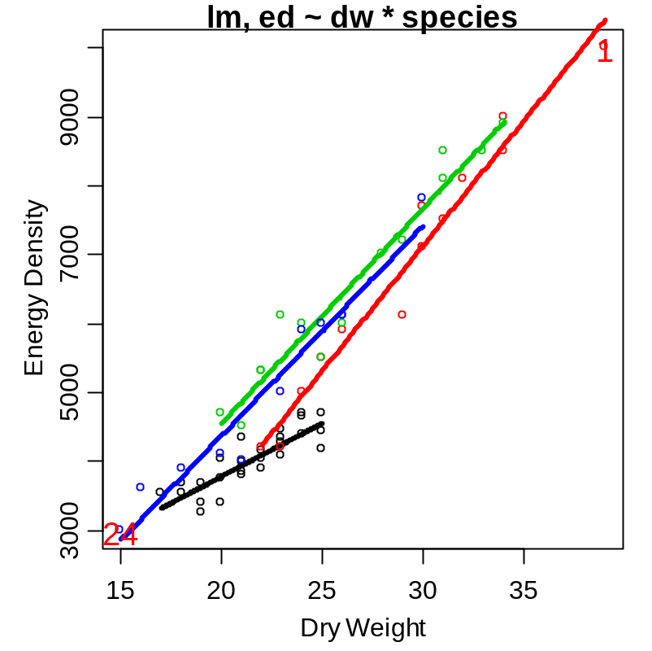
> anova(lm1)
Analysis of Variance Table
Response: ed
Df Sum Sq Mean Sq F value Pr(>F)
dw 1 170693154 170693154 1858.966 < 2.2e-16 ***
species 3 10592036 3530679 38.452 1.258e-13 ***
dw:species 3 4105617 1368539 14.904 3.002e-07 ***
Residuals 56 5142008 91822

> summary(lm1)
Call: lm(formula = ed ~ dw * species)

Coefficients:
Estimate Std. Error t value Pr(>|t|)
(Intercept) 702.75 560.79 1.253 0.21536
dw 154.19 25.94 5.945 1.87e-07 ***
speciesbluefish -4440.25 762.86 -5.821 2.97e-07 ***
speciesstripedbass -2378.34 740.18 -3.213 0.00218 **
speciesweakfish -2396.01 729.62 -3.284 0.00177 **
dw:speciesbluefish 208.31 31.29 6.657 1.27e-08 ***
dw:speciesstripedbass 157.62 31.61 4.986 6.29e-06 ***
dw:speciesweakfish 149.60 33.14 4.514 3.32e-05 ***

Residual standard error: 303 on 56 degrees of freedom
Multiple R-Squared: 0.973, Adjusted R-squared: 0.9696
F-statistic: 288.4 on 7 and 56 DF, p-value: < 2.2e-16

> comp.slopes(lm1)
Multiple comparison control procedures used: FDR

Multiple Slope Comparisons
comparison diff lwr upr raw.p adj.p
1 bluefish-bayanchovy 208.30952 145.62788 270.99117 0.00000 0.00000
2 stripedbass-bayanchovy 157.62055 94.29774 220.94336 0.00001 0.00003
3 weakfish-bayanchovy 149.60379 83.20906 215.99852 0.00003 0.00006
4 stripedbass-bluefish -50.68898 -101.08569 -0.29227 0.04873 0.05848
5 weakfish-bluefish -58.70573 -112.91192 -4.49955 0.03430 0.05145
6 weakfish-stripedbass -8.01676 -62.96310 46.92958 0.77116 0.77116

Slope Information
level slopes lwr upr raw.p adj.p
1 bayanchovy 154.1905 102.2341 206.1469 0 0
4 weakfish 303.7943 262.4567 345.1318 0 0
3 stripedbass 311.8110 275.6128 348.0092 0 0
2 bluefish 362.5000 327.4355 397.5645 0 0

> detach(FED)
> FED1 <- FED[FED$species!="bayanchovy",]
> FED1$species <- factor(FED1$species)
> attach(FED1)

> lm2 <- lm(ed~dw*species)
> anova(lm2)
Analysis of Variance Table
Response: ed
Df Sum Sq Mean Sq F value Pr(>F)
dw 1 104962559 104962559 838.6208 < 2.2e-16 ***
species 2 2583571 1291785 10.3210 0.0003476 ***
dw:species 2 556352 278176 2.2225 0.1247887
Residuals 32 4005150 125161

> comp.intercepts(lm2)
Tukey HSD on adjusted means assuming parallel lines.
comparison diff lwr upr p.adj
1 stripedbass-bluefish 631.3980 291.1082 971.6878 0.0001843341
2 weakfish-bluefish 506.4749 144.5318 868.4180 0.0044160914
3 weakfish-stripedbass -124.9231 -480.8922 231.0461 0.6693967026

Mean adjusted values at a covariate value of 26.1052631578947
bluefish stripedbass weakfish
5828.663 6460.061 6335.138

> plot.fit(lm2,xlab="Dry Weight",ylab="Energy Density")
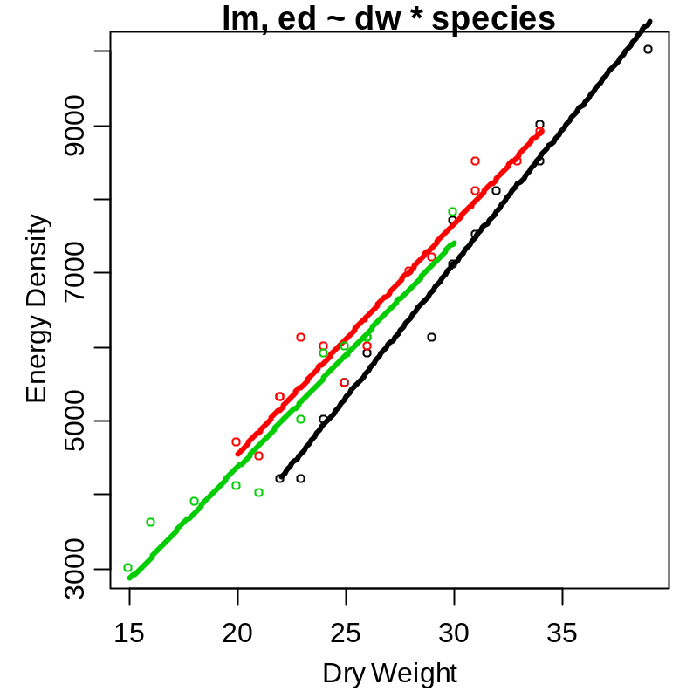

R Commands

library(NCStats)
library(MASS)
FED <- read.table("FishEnergyDensity.txt",head=T)
str(FED)
attach(FED)
lm1 <- lm(ed~dw*species)
plot.resid(lm1,loess=F)
ncv.test(lm1)
ad.test(lm1$residuals)
plot.diag(lm1)
plot.fit(lm1,xlab="Dry Weight",ylab="Energy Density")
highlight(ed~dw,pts=c(1,24))
anova(lm1)
summary(lm1)
comp.slopes(lm1)
detach(FED)
FED1 <- FED[FED$species!="bayanchovy",]
FED1$species <- factor(FED1$species)
attach(FED1)
lm2 <- lm(ed~dw*species)
anova(lm2)
comp.intercepts(lm2)
plot.fit(lm2,xlab="Dry Weight",ylab="Energy Density")

